LEARNER GUIDE

New Model Library: Pandemic Effects and Library Directions
READ THE BRIEFING: oc.lc/nml-briefing
BRIEFING DESCRIPTION: The COVID-19 pandemic impacted libraries of all types around the world, requiring library leaders to respond to rapidly shifting community and institutional needs. OCLC Research interviewed 29 library leaders from 11 countries to capture their experiences during the pandemic and understand what they envision for their libraries moving forward. We describe these transformations—how leaders strategically adapted to meet evolving needs and expectations—as movements toward a New Model Library.
The resulting framework, which categorizes the transformations in terms of three experiences and four areas of impact, can help you find common ground with peers and identify new ideas and directions for your strategic planning. We hope you find it useful as a way to share your own experiences and ideas for your New Model Library.
What are your goals for reading this briefing?
Personal goals
Team goals

Reflect
Complete this activity on your own or as a team.
Think about the changes that you made (or couldn’t make!) during the pandemic. Think about the new community needs and expectations that have emerged and are likely to stay.
In the framework on the next page, write down 1) what’s going well that you want to continue, and 2) what changes you want to make.
Once you’ve put your activities into the framework, look at which cells are full and which are empty. Is this a good reflection of your library’s mission, values, and goals? Is it a good reflection of your community’s needs? This reflection is meant to help you step back from your day-to-day activities to identify how well they are serving you, your community, and your organization. Every cell does not need to be filled in. In fact, empty cells can be an indication that you are well-aligned with what you need to do for your library and community.
Finally, circle 2–3 items in your grid that are the highest priority for you right now. Put a star next to the 2–3 items that will be the highest priority during the next five years.

 | 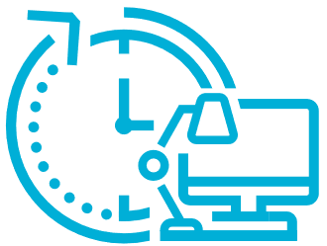  WORK EXPERIENCES  Flexible and changing  job experiences | 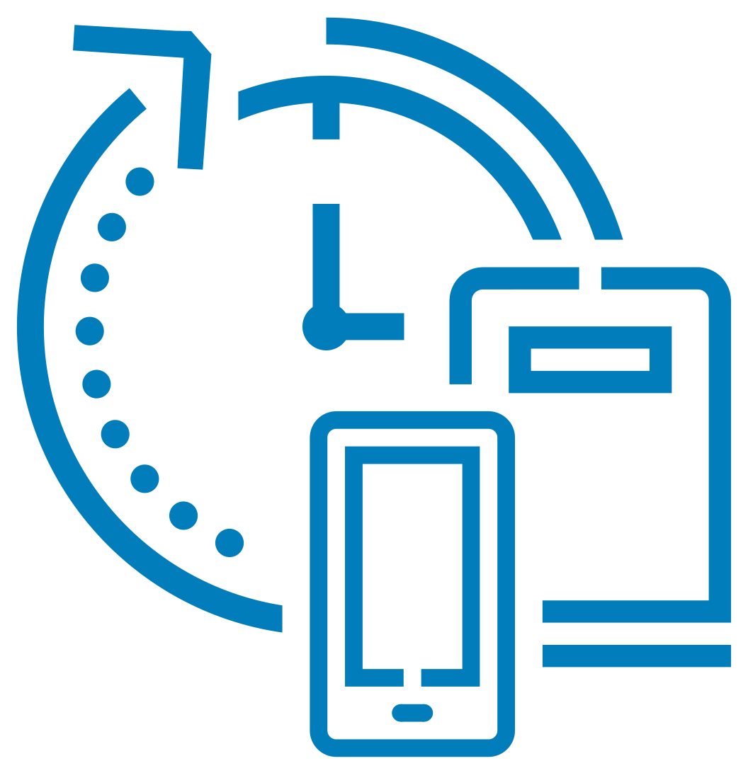  COLLECTIONS EXPERIENCES  Physical, digital, and  electronic resources | 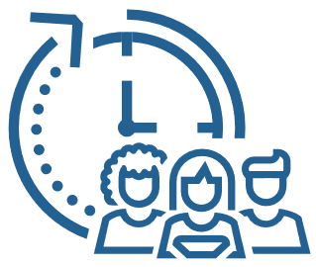  ENGAGEMENT EXPERIENCES  In-person and  virtual connections
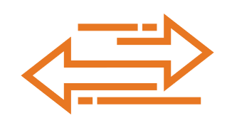  AGILITY | Flexible remote work options are working well
COLLABORATION
VIRTUALIZATION |  |  | Need to develop video tutorials
SPACE

Discuss
Compare your grid with others in your team and with other stakeholders in your library or community, such as trustees and collaborators. Discuss:
- Where is there agreement? Where is there divergence?
- Why did you choose those priorities?
Now, take a more long-term, holistic view of your library. Discuss:
- Which of the three experiences will undergo the most change going forward?
- In which of the four areas of impact is your library’s strongest?
- In five years, what do you want your New Model Library to look like?
- What are the biggest challenges you anticipate in getting to your New Model Library? How can you use your library’s strengths to overcome them?

Take action
Complete this activity on your own or as a team.
Now that you’ve had a discussion about your New Model Library, select one of the long-term priority items from your grid and answer the following questions.
- What is the outcome you hope to achieve?
- Who will you need to work with to achieve it?
- What are the major milestones you will need to reach in order to achieve this outcome?
- What steps will you take in the next month to act on this?

