To: VIAF Council
From: OCLC
Re: 2013 Annual Report to VIAF Council
Date: 12 August 2013 (revised 13 November 2013)

The VIAF™ (Virtual International Authority File) combines multiple name authority files into a single name authority service. It has become a significant resource for library authority work and a hub of import for authoritative linked data on the Web.
Since VIAF’s transition to become an OCLC service in early 2012, the number of agencies participating has grown from 19 agencies in 22 countries to 34 agencies in 28 countries. Twenty-three (23) of the VIAF Contributors are national libraries, and an additional 10 national libraries provide data to VIAF through consortia or other arrangements.

VIAF Contributors and Data Sources
The following agencies have become new VIAF Contributors since 2012:
- Vlaamse openbare bibliotheken (Flemish Public Libraries)
- Système Universitaire de Documentation (Sudoc) (University Documentation System) [France]
- Koninklijke Bibliotheek (National Library of the Netherlands)
- Nasjonalbiblioteket (National Library of Norway)
- Dansk BiblioteksCenter (Danish Library Center)
- 国立国会図書館 (National Diet Library)
- National Library Board, Singapore
- Latvijas Nacionālā bibliotēka (National Library of Latvia)
- Biblioteka Narodowa (National Library of Poland)
- IZUM (Institut informacijskih znanosti) (IZUM (Institute of Information Science))
- Nacionalna i sveučilišna knjižnica u Zagrebu (National and University Library in Zagreb)
- Biblioteca de Catalunya (National Library of Catalonia)
- Bibliothèque nationale de Luxembourg (National Library of Luxembourg)
- المكتبة الوطنية اللبنانية (Bibliothèque nationale du Liban | Lebanese National Library)

Figure 1: Agencies added to VIAF (note: 2013 data is to July)*
*This count includes the host agency, OCLC, and the following (current as of July 31, 2013):
Two agencies that have not entered into an updated contract:
- Országos Széchényi Könyvtár (National Széchényi Library)
- Российской государственной библиотеки (Russian State Library)
And a third agency with a contract pending:
- IZUM (Institut informacijskih znanosti) (IZUM (Institute of Information Science))

Reduction: After initially providing their full authority file, BIBSYS chose to reduce the data provided for VIAF to authority and bibliographic records with Norwegian national status.

VIAF has also added a non-Contributor source file, Wikipedia (http://www.wikipedia.org), and with assistance from the OCLC Wikipedian-in-Residence, Max Klein, VIAF links can now be automatically appended to appropriate Wikipedia articles.

An exploratory collaboration with the Syriac Reference Portal (http://www.syriac.ua.edu/demo ) has proven very successful and will be transitioned to make the Syriac Reference Portal an additional non-Contributor source file for VIAF.

VIAF has worked closely with the ISNI organization (http://www.isni.org ) to align ISNI (International Standard Name Identifier) identifiers and VIAF clusters and to enrich VIAF with ISNI links.

VIAF Data Inputs and Outputs
The source data upon which VIAF is built has grown to 33 million authority records and 107 million bibliographic records.
Source authority records by type:
Personal: 26.4 million
Corporate: 5.1 million (includes conferences)
Geographic: 0.4 million (mostly jurisdictional)
Uniform titles: 1.8 million

Figure 2: Source authority records by type (Source: OCLC)

Source name | Source | Personal name records | Corporate and/or conference name records | Geographic name records | Uniform title records | Total number of authority records | % of records associated with bib data | % of Records matching at least one other source | Total number of matches | Number of bibliographic records for the source
ABES (Agence Bibliographique de l'Enseignement Supérieur) | SUDOC | 2,022,275 | 227,918 | 0 | 21,594 | 2,271,804 | 13% | 36% | 2,750,526 | 10,902,918
Biblioteca de Catalonia | BNC | 22,010 | 0 | 0 | 0 | 22,010 | 51% | 46% | 27,388 | 72,620
Biblioteca Nacional de España | BNE | 371,661 | 62,179 | 591 | 101,333 | 535,765 | 76% | 53% | 966,644 | 2,439,168
Biblioteca Nacional de Portugal | PTBNP | 253,900 | 67,164 | 0 | 0 | 321,064 | 97% | 31% | 404,878 | 850,398
Bibliotheca Alexandrina (Egypt) | EGAXA | 34,494 | 350 | 8 | 11 | 34,863 | 98% | 61% | 69,418 | 148,230
Bibliothèque nationale de France | BNF | 1,416,998 | 317,668 | 6,525 | 154,784 | 1,895,975 | 86% | 68% | 4,311,472 | 12,721,075
BIBSYS (Norway) | BIBSYS | 54,270 | 5,280 | 0 | 87 | 59,637 | 80% | 25% | 43,033 | 5,817,367
Deutsche Nationalbibliothek | DNB | 7,463,182 | 1,697,890 | 262,747 | 190,448 | 9,614,660 | 43% | 28% | 7,214,965 | 20,350,290
Flemish Public Libraries | VLACC | 4,539 | 729 | 0 | 0 | 5,268 | 93% | 82% | 23,243 | 998,628
Getty Union List of Artist Names | JPG | 182,182 | 33,107 | 0 | 0 | 215,289 | 0% | 31% | 219,916 | 0
Istituto Centrale per il Catalogo Unico (Italy) | ICCU | 45,189 | 19 | 0 | 0 | 45,208 | 0% | 13% | 23,788 | 41,638
Koninklijke Bibliotheek (the Netherlands) | NTA | 2,445,198 | 0 | 0 | 0 | 2,445,198 | 96% | 60% | 4,504,486 | 17,121,576
Library and Archives Canada | LAC | 428,345 | 187,443 | 11,301 | 54,633 | 681,722 | 66% | 50% | 841,119 | 1,531,635
Library of Congress/NACO | LC | 5,820,102 | 1,603,886 | 132,001 | 1,115,352 | 8,671,341 | 51% | 44% | 9,082,658 | 13,802,291
National Diet Library | NDL | 797,932 | 186,262 | 7,424 | 2,998 | 994,616 | 94% | 25% | 702,402 | 4,534,179
National Library Board (Singapore) | NLB | 4 | 2 | 198 | 0 | 204 | 0% | 100% | 221 | 0
National Library of Australia | NLA | 706,515 | 208,241 | 778 | 88,619 | 1,004,153 | 0% | 49% | 1,476,789 | 0
National Library of Denmark (test) | DBC | 2,326 | 0 | 0 | 0 | 2,326 | 98% | 30% | 2,801 | 3,854
National Library of Israel | NLI | 459,798 | 58,939 | 0 | 1,394 | 520,131 | 50% | 60% | 1,348,237 | 1,209,253
National Library of Poland | NLP | 576,504 | 76,169 | 38 | 44,277 | 696,991 | 80% | 67% | 1,456,264 | 1,704,093
National Library of Sweden | SELIBR | 149,434 | 17,254 | 157 | 6,132 | 172,977 | 59% | 53% | 494,776 | 2,073,852
National Library of the Czech Republic | NKC | 541,155 | 125,876 | 0 | 0 | 667,031 | 50% | 50% | 1,463,446 | 2,255,742
National Széchényi Library (Hungary) | NSZL | 31,734 | 1,913 | 2 | 78 | 33,727 | 99% | 53% | 59,746 | 1,750,927
NUKAT Center (Poland) | NUKAT | 1,098,541 | 114,257 | 67 | 0 | 1,212,865 | 97% | 80% | 3,285,683 | 4,882,852
RERO (Switzerland) | RERO | 77,283 | 41,336 | 247 | 2 | 118,869 | 99% | 79% | 433,529 | 1,093,307
Russian State Library | RSL | 997 | 0 | 0 | 0 | 997 | 0% | 30% | 1,223 | 0
Swiss National Library | SWNL | 32,838 | 5,237 | 177 | 1 | 38,253 | 100% | 63% | 85,552 | 379,104
Vatican Library | BAV | 266,530 | 34,532 | 2,942 | 5,408 | 309,412 | 94% | 63% | 835,440 | 626,862
z-eXtensible authorities | XA | 204 | 5 | 0 | 0 | 209 | 0% | 100% | 1,230 | 0
z-Wikipedia | WKP | 1,075,291 | 0 | 0 | 0 | 1,075,291 | 0% | 31% | 1,396,207 | 0
 |  | 26,381,431 | 5,073,656 | 425,203 | 1,787,151 | 33,667,856 |  |  | 43,527,080 | 107,311,859

VIAF processes the source data to yield 24.2 million clusters with 21 million links between records.

Clusters by type:
Corporate 3,770,650
Geographic 406,799
Personal 18,067,989
Expression 287,211
Work 1,685,745

Figure 3: VIAF Clusters by Type (July 2013) (Source: OCLC)

VIAF Utilization

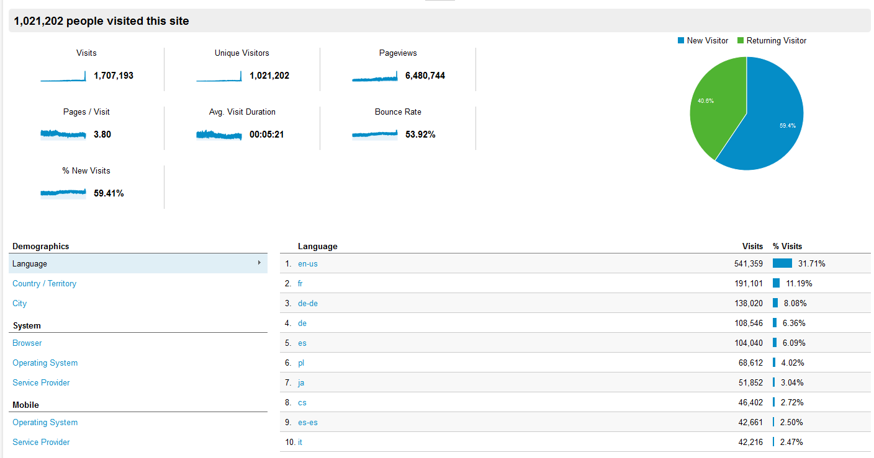
Figure 4: http://viaf.org metrics (1 Jan 2012 through 30 June 2013) (source: Google Analytics)

Figure 5: All Traffic to viaf.org (1 Jan. 2012 to 30 June 2013) (source: Google Analytics)

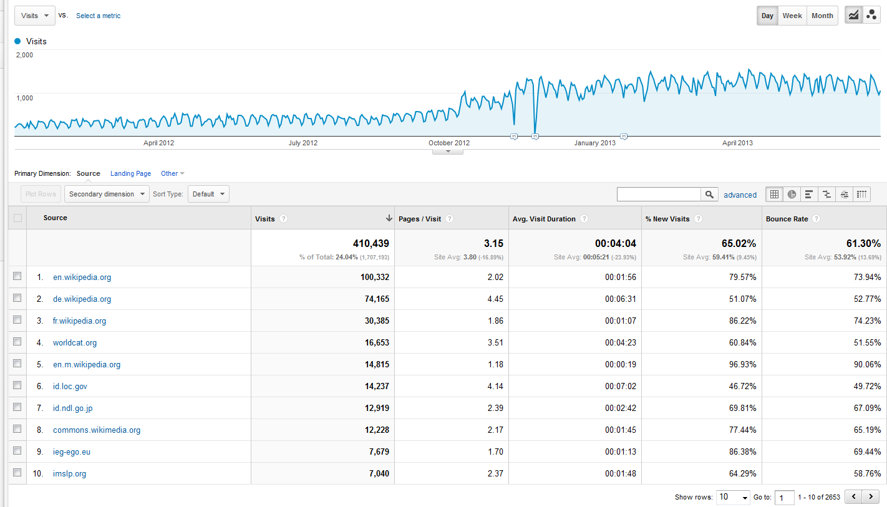
Figure 6: Referrals [subset of All Traffic] to viaf.org (1 Jan. 2012 to 30 June 2013) (source: Google Analytics)

VIAF Service Changes and Enhancements
OCLC Research continued to make enhancements to VIAF including:
- Continuing improvements to clustering
- Better date parsing (7/2012)
- Shifted to Hadoop environment (10/2012)
- Wikipedia added as a full source file (10/2012)
- Better matching of corporate names and single date names (11/2012)
- ISNIs added to clusters (11/2012)
- Updated auto-suggestor (12/2012)
- Number of work records increased significantly
- Dramatically faster VIAF builds implemented and swifter availability of VIAF bulk downloads
- Made VIAF ID assignments more persistent across re-clustering activity
- VIAF infrastructure shifted from OCLC Research to OCLC Production Control (6/2013)
- Added N-Triples to VIAF's RDF bulk distribution
- Improved handling of undifferentiated name records
Updates to the Japanese, French, German, and Spanish-language interfaces for viaf.org have been made with the assistance of VIAF Contributors: the National Diet Library (Japanese), the Bibliothèque nationale de France (French), Deutsche Nationalbibliothek (German), and the Biblioteca Nacional de España (Spanish). Work continues within OCLC to transition operational aspects of VIAF from OCLC Research to OCLC’s production staff.
Following dialogue with the the Biblioteca Nacional de España (BNE) and the recent addition of data from the Biblioteca de Catalunya (BC), OCLC has established a Hispánica view option in viaf.org. Going forward, the BNE with the BC and other appropriate organizations will work with OCLC to increase the authority data available in VIAF from Spanish, Catalan, Basque, Galician, and Valencian data sources.

VIAF Outreach
OCLC staff have presented information about VIAF in a variety of settings including:
Titia van der Werf
Virtual International Authority File (VIAF) and International Standard Name Identifier (ISNI)
COAR 4th Annual Meeting, 8 May 2013, Istanbul, Turkey
Download the presentation (.ppt: 6.5MB/32 slides)
View on SlideShare
Thom Hickey
VIAF Update
EMEARC, 25 February 2013, Strasbourg, France
Download the presentation (.pptx: 1.4MB/14 slides)
View on SlideShare
Maximilian Klein
VIAF Data in Wikipedia & Wikidata
EMEARC, 25 February 2013, Strasbourg, France
Download the presentation (.pptx: 1.2MB/28 slides)
View on SlideShare
Eric Childress
VIAF for NAAC
NAAC Meeting, National Archives and Records Administration, 4-5 October 2012, Washington, D.C. (USA)
Download the presentation (.pptx: 5.4MB/43 slides)
View on SlideShare

Additionally, OCLC Research cooperated with Europeana to explore better clustering of Europeana metadata and the possibility of enriching Europeana data with VIAF identifiers (for more information, see http://www.oclc.org/research/activities/europeana.html )

VIAF Council
As part of the transition of VIAF to an OCLC service in 2012, the VIAF Council (VIAFC) was formed to advise OCLC about VIAF. All VIAF Contributors are invited to appoint an official member to the VIAFC.
The first Annual Meeting of the VIAFC took place in Helsinki, Finland on 10 August, 2012 in conjunction with the World Library and Information Congress, Barbara Tillett (Library of Congress) serving as initial VIAFC chair. The meeting was held at the National Library of Finland (Kansalliskirjasto).
The VIAFC heard presentations, elected a Chair, Vincent Boulet (Bibliothèque nationale de France), serving a 1-year term through 16 August, 2013, and a Chair-elect, Brigitte Wiechmann (Deutsche Nationalbibliothek) who will serve as Chair from 17 August, 2013 to the close of the VIAFC Annual Meeting in Lyon, France in August, 2014.
At the 2012 Annual Meeting, the VIAFC created two task groups:
- Group n°1 : Public presence of and advocacy for VIAF (promotion, communication on effective and possible reuses of VIAF clusters...)
- Group n°2 : Privacy issues (content of the VIAF records, e. g. the data available for a public display and free reuse, the distinction between public display and the data processed by the merging algorithm...)
A VIAF Workshop was held 25 February 2013 in Strasbourg, France in conjunction with OCLC EMEA Regional Council meeting. The VIAF Council held a virtual meeting 2 May 2013 to receive updates from OCLC staff and discuss other items of interest.
The second Annual Meeting of the VIAFC will be held 16 August, 2013 in Singapore at the Central Public Library, courtesy of the National Library Board of Singapore.

VIAF transitioned from a joint, experimental activity of the United States Library of Congress (LC), the German National Library (Deutsche Nationalbibliothek, or DNB) National Library of France (Bibliothèque nationale de France, or BnF) and OCLC to become an OCLC service in early 2012. For more information see the OCLC news announcement: http://www.oclc.org/news/releases/2012/201224.en.html
VIAF Contributors commit to participate in actively contributing to VIAF and VIAF Council. Non-Contributor data sources provide data only.
For more information about VIAF and Wikipedia, see http://www.oclc.org/research/news/2012/12-07a.html
Information about VIAFC meetings including presentations and minutes may be found here: http://www.oclc.org/viaf/news.en.html

